Project Proposal

- Title of the project:
Sarcasm Detection

- Brief on the project:
The goal of this project is to build a sarcasm detection model using deep learning algorithms and transformer based pretrained models available in hugging face. This will help identifying sarcastic headlines or posts.

- Deliverables of the project:
- An application to predict whether a given text is sarcastic or not.
- Detailed instruction how to analyze using user interface.

- Resources:
- Data set source:

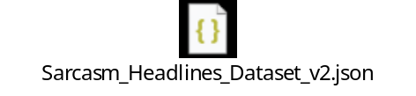
- Software:
- Visual Studio Code
- Jupyter Notebook
- Google Colab
- Github
- Streamlit Cloud

- References:
- Google Gemini 3.5 Flash

- Individual Details:
- Name : Abhijit Saha
- E-mail Id : abhijit250692@gmail.com
- Phone Number : +91 8549968520

- Milestones:

- Why sarcasm detection is important?

Sarcasm detection is a critical frontier in Natural Language Processing (NLP) because sarcasm fundamentally flips the intended meaning of a statement. Here is why sarcasm detection is highly relevant across different industries and research areas:

Brand Monitoring & Social Listening

- Preventing Misleading Metrics: Customers often use sarcasm to vent frustration (e.g., "I love waiting 45 minutes on hold with customer support! Wonderful service!").

- Accurate Sentiment Tracking: Standard NLP tools flag words like "love" and "wonderful" as positive. Sarcasm detection corrects this, preventing brands from miscalculating customer satisfaction indexes (CSAT) and Net Promoter Scores (NPS).

Market Research & Consumer Insights

- Product Feedback: Analysing reviews on platforms like Amazon or Reddit requires filtering out sarcastic praise to understand actual product flaws.

- Campaign Evaluation: Brands launching new advertisements can accurately gauge whether public mockery or genuine praise is trending online.

Content Moderation & Safety

- Cyberbullying & Harassment: Harmful or derogatory statements are frequently disguised as sarcastic jokes or "banter."

- Hate Speech Detection: Modern content moderation pipelines use sarcasm analysis to identify subtle, passive-aggressive hate speech and online toxicity that bypass traditional keyword filters.
Financial Markets & Algorithmic Trading

- Stock Market Sentiment: Quantitative trading algorithms scan financial news, Twitter/X, and forums (like WallStreetBets) to predict stock movements.

- Risk Mitigation: Misinterpreting a sarcastic post about a company's financial health can lead to incorrect automated trading decisions and financial loss.

Chatbots & Conversational AI

- Human-like Interaction: Virtual assistants (like Siri, Alexa, or customer support bots) need to recognize when a user is being sarcastic to respond with appropriate empathy or humour rather than a literal, robotic answer.

- Dataset Overview:
The dataset consists of 28619 records and 3 columns.
Column Name | Description | Data Type
is_sarcastic | Binary classification.  Sarcastic = 1  Non-sarcastic = 0 | Integer (ID)
headline | Text to classify as sarcastic or non-sarcastic | String (Alphanumeric)
article_link | Source of headline | String (Alphanumeric)

- Explore and pre-process data:

- Dataset consist of 28619 records which include 3 columns per record.

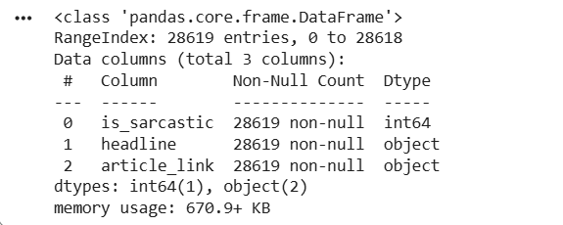

- article_link doesn’t have any correlation with target variable and won’t add any importance in the model building. Therefore, we are removing this columns from the dataset.

- There are no missing values in the dataset.

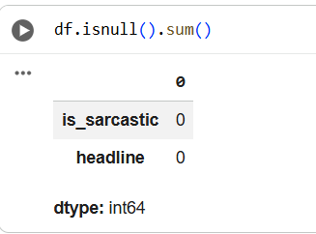

- There are 116 duplicate rows in the dataset.

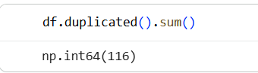

- Distribution of sarcastic and non-sarcastic data:

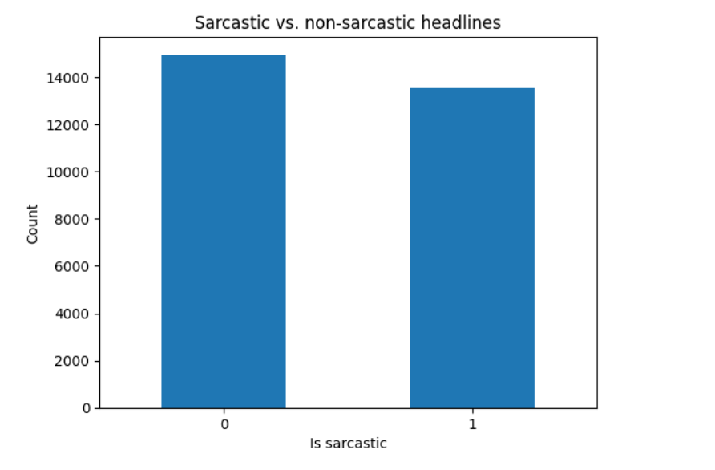

- Distribution of most commonly used words:

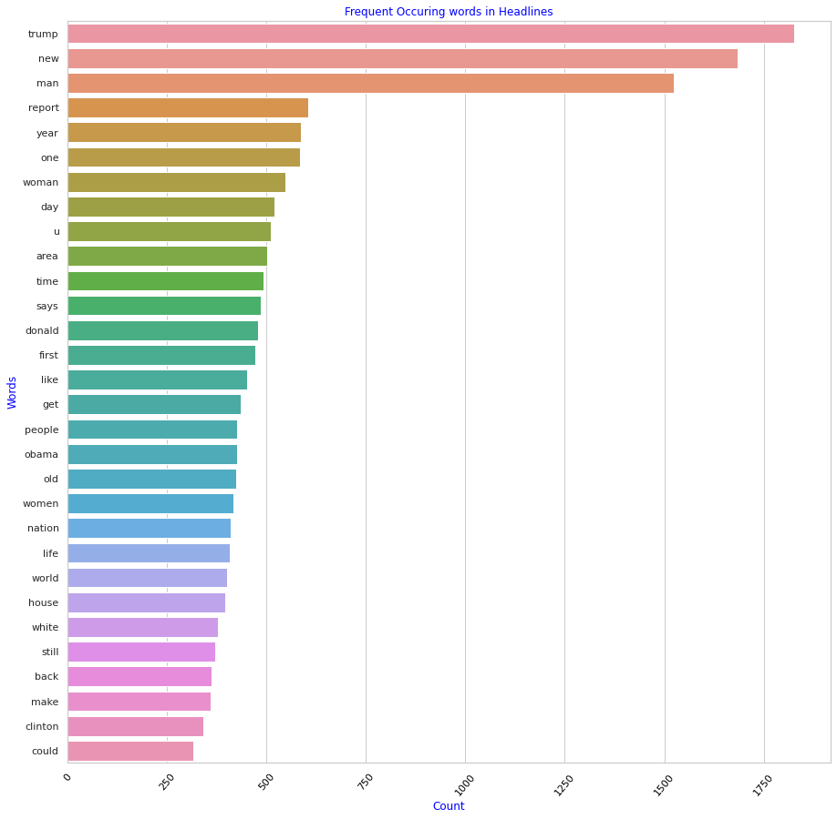

- Distribution of most commonly used sarcastic words:

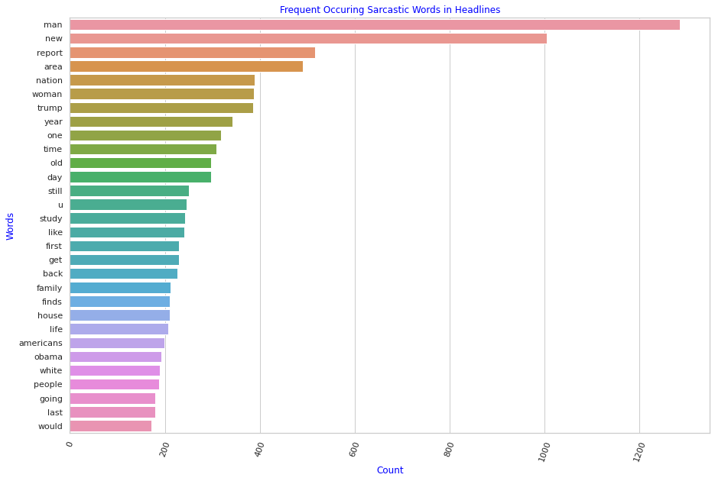

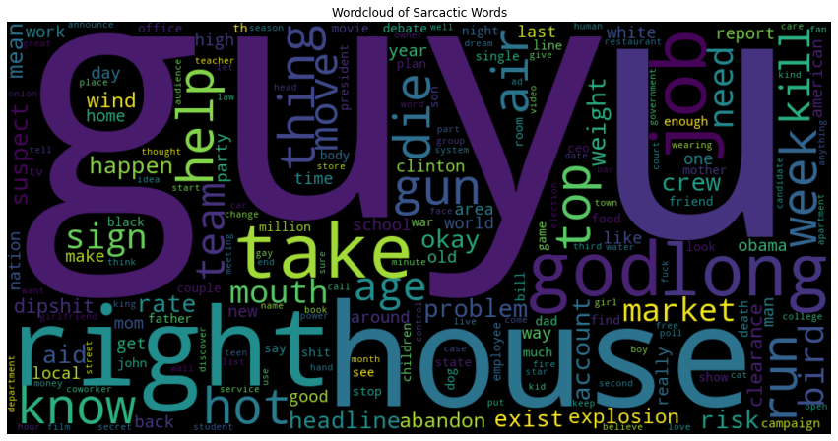

- Distribution of most commonly used non-sarcastic words:

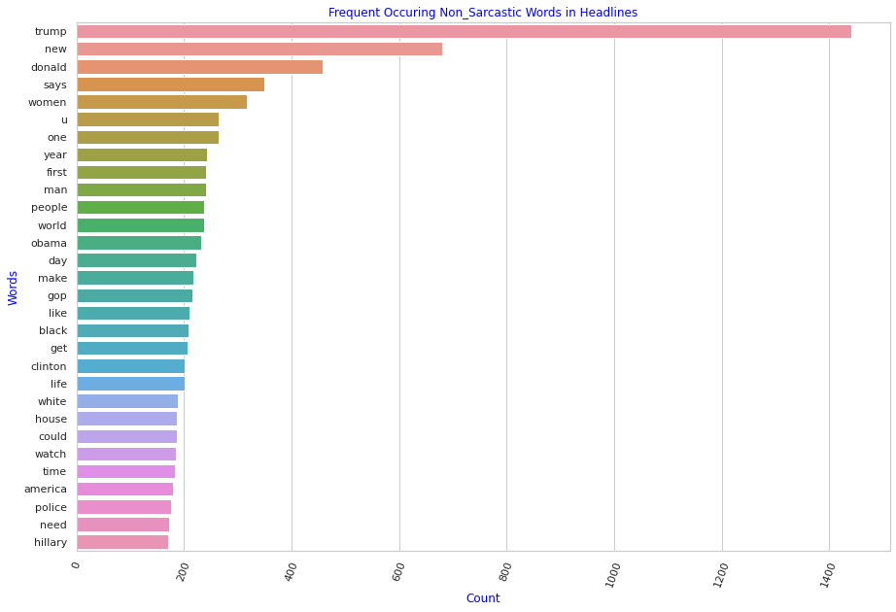

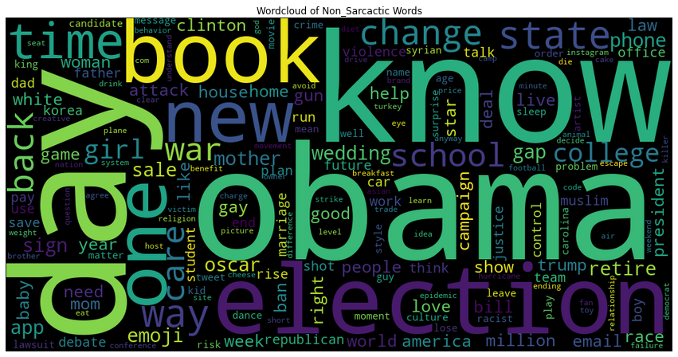

- Model building & evaluation:

- Model evaluation:

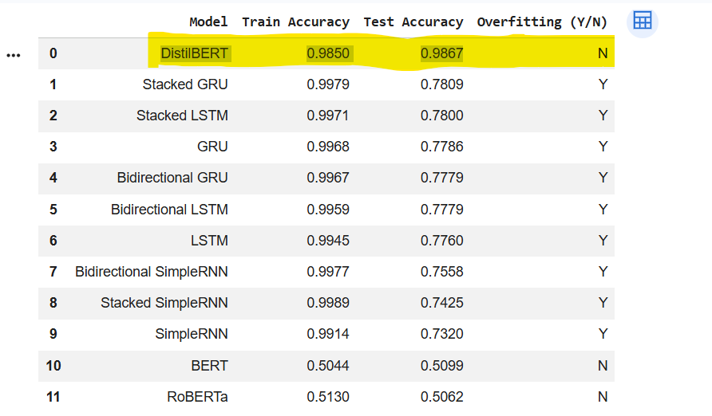

We have all combinations of RNN, LSTM & GRU algorithms. Stacked GRU performed best among these deep learning algorithms with 78.09% test accuracy.

We have tried few transformer based pre-trained models like BERT, DistillBERT and RoBERTa. DistillBERT performed best with 98.67 % test accuracy.

- Best Model :

DistillBERT is the best performing model with 98.67% test accuracy.

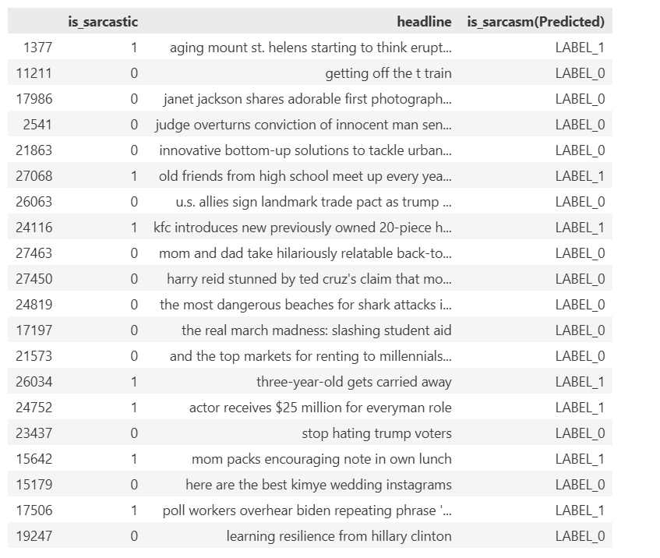

- Code:

Github : https://github.com/abhijit250692/Sarcasm-Detection/tree/main

- User Interface:

